HOT Ethical Data and Protection Checklist

This checklist should be completed for all new field mapping projects, and for all remote mapping projects in conflict or unstable areas using the HOT Tasking Manager.

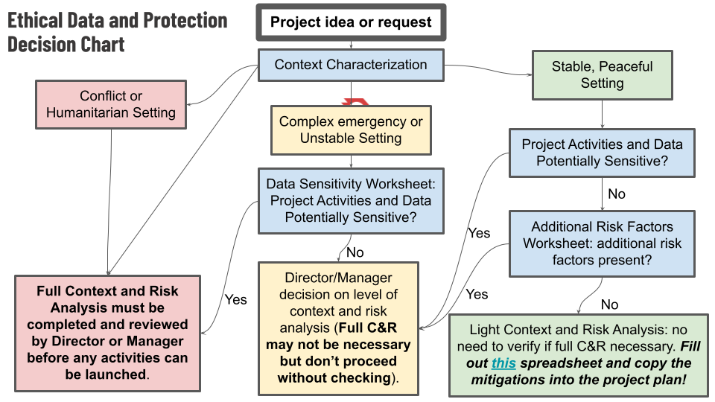

* **Context Characterization.** Use [this tool](http://placeholder) to assess if the *area you will be working in* is high (red), medium (yellow), or low (green).
* **Data Sensitivity Worksheet.** Use [this tool](http://placeholder) to assess if the *data you will be collecting* is sensitive and therefore risks harm to people.
* **Additional Risk Factors Worksheet.** Even non-sensitive data in peaceful, stable locations can present significant risks during exceptional periods or events. Use [this tool](http://placeholder) to determine if additional risk factors are present.
* **Risk Assessment Completed** (check one of the three below):
  + If **GREEN**, complete this risk assessment template (30-60 minutes recommended) and retain the completed spreadsheet with the project documents. If the risks after mitigation do not go into the red, you’re done; proceed with your project!
  + If **YELLOW**, discuss with your director or the person delegated by your director to manage Protection risk. They will decide if you proceed with the green-style streamlined risk assessment or the red-style full risk assessment.
  + If **RED**, your project has a high Protection risk and you must complete a full risk assessment before proceeding. Contact the Data team director, or your Hub director for further instructions.